**EXPERIMENT NO 1**

**PART A**

**SOURCE CODE:**

import java.util.*;

class calculator

{

public static void main(String args[])

{

Scanner sc=new Scanner(System.in);

int x=sc.nextInt();

int y=sc.nextInt();

while(true)

{

System.out.print("enter the operation \n 1:add \n 2:sub \n 3:multiply \n 4:divide \n 5:mod 6:exit \n");

int c=sc.nextInt();

switch(c)

{

case 1:System.out.println(x+y);break;

case 2:System.out.println(x-y);break;

case 3:System.out.println(x*y);break;

case 4:System.out.println((float)x/y);break;

case 5:System.out.println(x%y);break;

default: System.out.println("error");

}

if(c==6)

break;

}

}

}

**OUTPUT:**

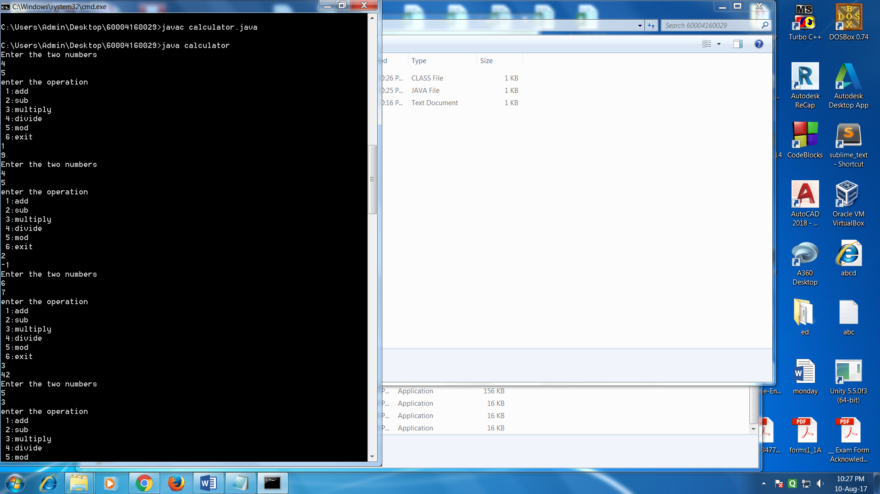

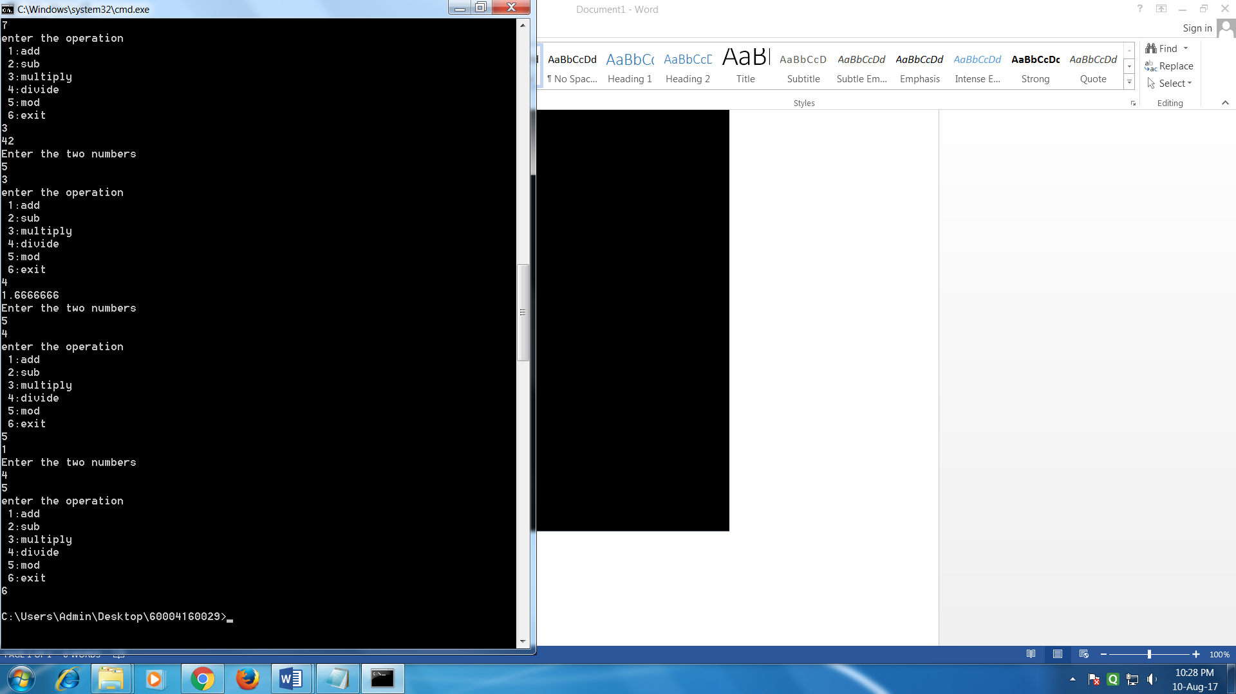

**PART B**

**SOUURCE CODE:**

import java.util.*;

class sample

{

public static void main(String args[])

{

System.out.println("ENTER THE COEFFICIENTS");

Scanner sc=new Scanner (System.in);

int x=sc.nextInt();

int y=sc.nextInt();

int z=sc.nextInt();

int d=(y*y)-(4*x*z);

if(d<0)

System.out.println("the roots are img");

else

{

double a=(-y+Math.sqrt(d))/(2*x);

double b=(-y-Math.sqrt(d))/(2*x);

System.out.println("the roots are "+a+" "+ b);

}

}

}

**OUTPUT:**

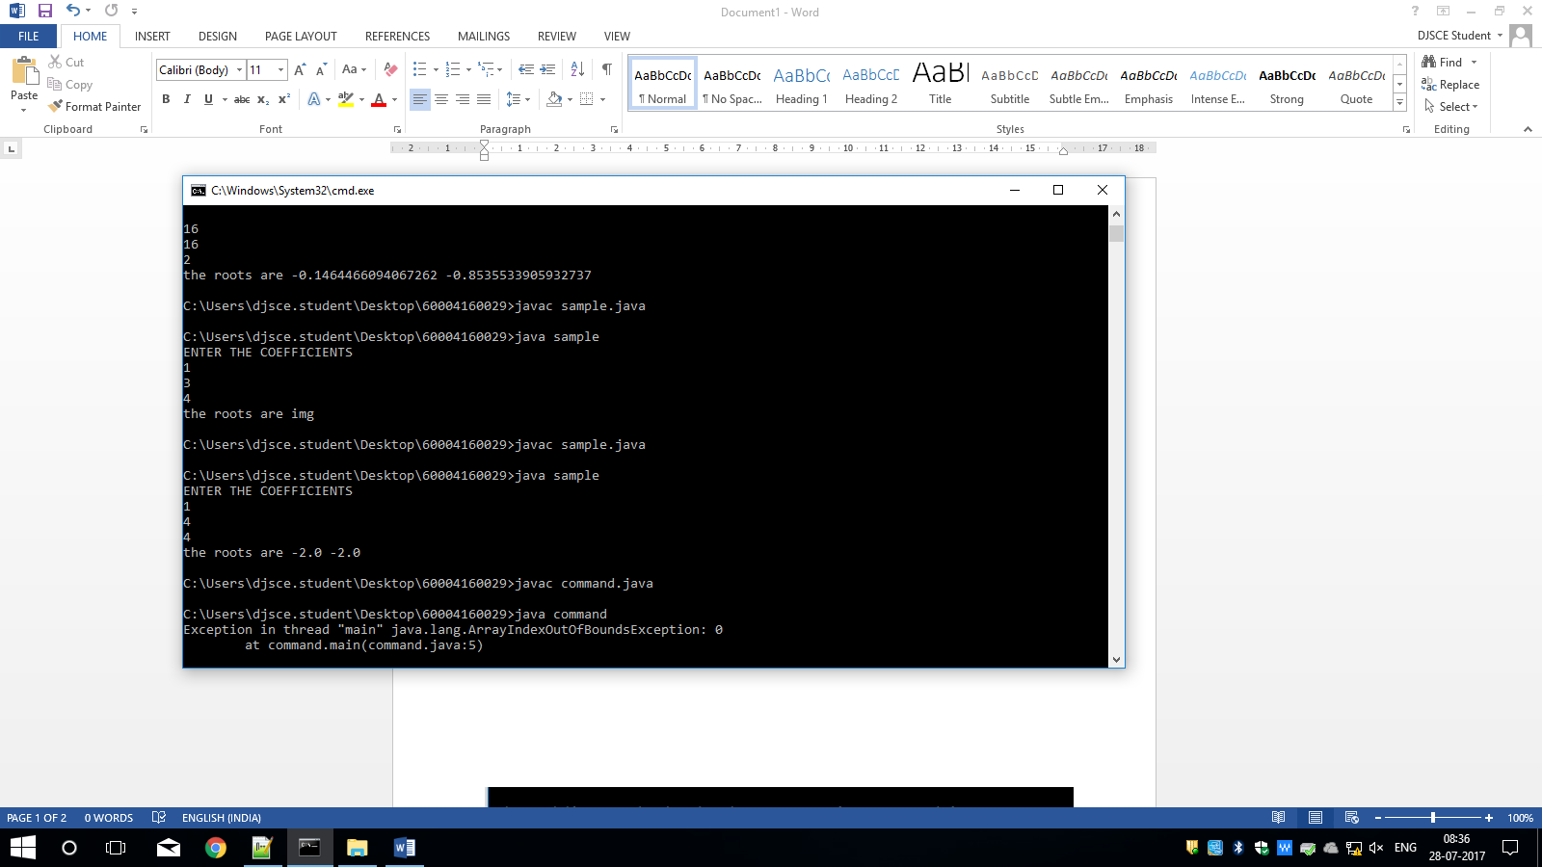



**PART C:**

**SOURCE CODE:**

class operators

{

public static void main(String args[])

{

byte a=10,b=10,e=15;

boolean c=true;

boolean d= false;

System.out.println("Ans 1 ="+(a++ - ++a));

System.out.println("Ans 2 ="+(--b - b-- * a++ ));

System.out.println("Ans 3 ="+(~a));

System.out.println("Ans 4 ="+(~b));

System.out.println("Ans 5 ="+(!d));

System.out.println("Ans 6 ="+(!c));

System.out.println("Ans 7 ="+(10*6/5+3-1*4/2));

a=3;b=3;

System.out.println("Ans 8 ="+(a<<2));

System.out.println("Ans 9 ="+(b>>3));

a=21;byte s=-1;

/*System.out.println(Byte.toBinaryString(s)); System.out.println("Ans 10="+(s>>1)); ans is -2*/

System.out.println("Ans 10="+(byte)(s>>>29));

System.out.println("Ans 11="+(a<b&&a>e));

System.out.println("Ans 12="+(a&b));

System.out.println("Ans 13="+(a|b));

System.out.println("Ans 14="+(a>b||a<e));

int min =a>b?a:b;

System.out.println("min "+ min);

}

}

**OUTPUT**:

